Amanda Wade
Professor Hope
Visual Communications
Final Paper

Female athletes representation in male and female dominated magazines

Abstract:
Athletics has been associated with men and the power and strength that they possess since the concept of sport began. Being a male dominated arena, female athletes have struggled to break barriers and cross boundaries that were deemed by society as masculine. As females step onto the courts and fields, they continue to fight the lesbian stereotype that is associated with the term “female athlete”. Although their athletic participation seems to be accepted, their representation within magazines remains feminizing and sexualizing. This study examines the reason why female athletes choose to portray themselves in the sexual light and compares the female athlete images in male oriented magazines and female oriented magazines.

Creating the stereotype:
The male dominated sport society has been changing and has become more accepting of female athletes. Primarily after the passage of Title IX, as part of the education amendment passed in 1972, women were not only breaking into the work force, they were stepping out onto the fields. As the percentage of female athletes increased, the stereotypes placed upon them grew stronger and stronger. These stereotypes, which are still current in today’s attitudes toward athletes, play a critical role in the way female athletes present themselves in magazines.
Female athletics was a hard concept for many critics to accept. Scott, and Derry (2005) stated, “it is unfeminine to be too strong, too muscular, too tough, too competitive, or too much better than the boys” (p. 196). As female athletes began to take up sports there were numerous activities that were considered acceptable for the female gender to participate in. Those sports included figure skating, gymnastics, swimming, golf and other non-team sports. Sports such as basketball, soccer and boxing involved too much physical contact and competition based on society’s standards, which drew negative attention to the female athletes who participated in them. The homosexual stereotype of Lesbianism started targeting female athletes who chose to participate in “masculine activities”
As more and more females picked up a sport the idea of “mannish lesbianism” was created and aimed at the athletic girls (Griffin 1992, p. 217). This concept was defined by Griffin as, “those who have a depraved sexual appetite and preference for masculine dress and activity” (1992, p. 217). The connection between lesbians and athletes was made because “lesbians were assumed to be masculine creatures who rejected their female identity and roles as wives and mothers” (p. 218). Females who chose sports over traditional roles were deemed masculine and therefore, must be homosexual, according to the social stereotype.

Act like a lady:
As this stereotype arose, many female athletes were taught and told how to act off the playing fields. The practice of acting like a lady was enforced to stray away from the lesbian image assigned to the athletes. The requirements included wearing dresses, learning how to apply makeup and style hair, and to be seen in public with boyfriends (Griffin, 1992, p. 220). It was understood by female athletes that their natural look, as an athlete, was not attractive, nor acceptable, and their image had to be “femmed up” to compensate for their athleticism (Griffin 1992, p. 221). By calling attention to their femininity, the threat of lesbianism was diminished (Duncan 2006, p. 240). A primary way to reveal an athlete’s feminine side has been through the media, specifically magazines.
Female athletes have barely existed in the pages within sports magazines. When they are presented, they are feminized, shown with their husbands, with children, dressed up or in passive poses. Rarely are they shown in their athletic environment. The images that do reveal their athletic talent are downplayed through the verbiage used to describe the image. Most often, the athlete is characterized as pretty, or emotional, while her strength and power remains unnoticed. Media images of female athletes have been focused on feminizing them. Over time, however, the hyperfemininity of female athletes turned into hypersexuality. The astonishing and sad fact is that some of the female athletes themselves approve the images. In this generation a small percentage of female athletes are helping the process of sexualization along (Hastings 2000, p. 259). Many Olympians say that they are proud of the hard lean muscular bodies they have developed and are proud to show them off (Hastings 2000, p. 259).

Postfeminist athletes:
The reason why many female athletes choose to represent themselves as sexual objects is because they agree with postfeminists and the idea that the images they pose for show them as empowering and liberating females. According to postfeminists the female athletes decision to display their body “demonstrates that they are in fact in control of how the images are projected” (Carty 2005, p. 134). There are many examples of female sexualized images in which the athlete argues that they represent strength and hard work.

Images of power?
At the completion of the 1999 Women’s World Cup Championship game the focus was not on the game winning penalty kick scored by Brandi Chastain, but rather on her actions after the kick. The media went wild in capturing the image of Chastain on her knees with her jersey ripped off revealing her torso and black sports bra (Hastings 2000, p. 258). This image appeared on the cover of Sports Illustrated and portrayed Chastain in both a sexualized and powerful light (Image 1). There was power in the image because Chastain was shown on the field after a victory celebrating in much the same way that a man would after scoring the game-winning goal. The difference was she was the first girl to take her shirt off, and while the sports bra covered her up, the image of her body was still feminizing. Contrary to this powerful image, Chastain chose to pose for two Nike ad’s in Gear Magazine in October of 1999. The first one, (Image 2) Chastain appears childlike with her mouth open in laughter as she covers her nude body up with a soccer ball and hugs her chest. The second image followed the same focus (Image 3). Chastain, who looks almost as if she’s in pain, as her teeth are clenched to force a smile, is hunched over holding two soccer balls that cover her breasts and her pelvis. She is standing in her Nike cleats and looks rather uncomfortable, or embarrassed, which contradicts her argument for these images. Chastain claims that she was “showing off the muscles and toned body she had earned through intense physical training and that her appearance in the photo did not objectify her body” (Carty 2005, p. 137-138). Instead she says that the image was a statement of strength and athleticism, and shows a body that she is proud of (Carty 2005, p. 138).
Chastain is not the only female athlete to share this frame of mind. U.S.A. Olympic swimmer Jenny Thompson also posed for Sports Illustrated to, as she would say, “display a muscular athletic form” (Hastings 2000, p.258). Thompson posed wearing a red white and blue swimsuit bottom, resembling the American flag and covered her breasts with clenched fists (Image 4). The purpose of this image was to “show off muscles rather than promote any kind of sex appeal” (Carty, 2005, p. 138). While displaying muscular strength in this image may be evident, why couldn’t Thompson wear the second piece of that bathing suit to cover her chest and demonstrate her strength in the pose? As the director of the Tucker Center for Research on girls and women in sports at the University of Minnesota, Mary Jo Kane remarks, “It’s not clear to me which muscle group the naked breast belongs to” (Hastings 2000, p. 258). This statement negates Thompson’s argument that her pose was supposed to reveal strength, and had nothing to do with sexuality. Her strength may be exposed, but so are her feminine breasts.
A Canadian swimmer, Marianne Limpert also says that if a female athlete is proud of her body that she has worked many hours a day for, she has the right to show it off. Athletes are not obliged to pose, it is up to them if they want to or not (Maloney 2000, p. 260). As these female athletes and postfeminists would argue, these images allow women to revalue their bodies as a source of pleasure, freedom and power (Carty 2005, p. 138). These athletes however, are missing the bigger picture. While the media continues to focus on femininity and sexuality of the athletes their credibility as an athlete decreases. Soon enough the athlete isn’t thought of as an athlete, but as a sexual object of desire. A prime example of this is Anna Kournikova, and her increased popularity over her attractive good looks as opposed to her athletic ability.
Kournikova (who has never won a tennis tournament) has been presented numerous times in magazines. One of her advertisements for Berlei shock absorbing bras in England had a tag line that read “only the ball should bounce” as Kournikova stands in the Berlei bra and her panties (Image 5). While the athletes feel that they are demonstrating power, they fail to recognize that very rarely are they portrayed in their sport environment. Kane and Greendorfer (1994) acknowledge this fact and state that:

“[B]y portraying female athletes as feminized and sexualized others, the media
trivialize and therefore undermine their athletic achievements. This type of media
portrayal results in constructions of female athleticism as less important than male
athleticism (p. 31).

Radical feminists:
The sports world is dominated by men, and while the postfeminists and athletes feel powerful in their images, they fail to acknowledge the counter argument, that of the radical feminists. Radical feminists say that the feminization and sexualization of female athletes is constructed in a male dominated society. In general men control sports magazines and make up the majority of the viewing/reading audience. While female athletes feel that their sexuality proves that they are powerful, those viewing the images, (men) use them to discredit women and diminish their strength. Smith (2006) points out that “men find ‘high-performing women athletes a threat to their male sports bastion’ and the hypersexualized images of women athlete’s function to normalize women athletes for men in the sports culture” (p. 172). Even though Chastain, Thompson and Kournikova feel empowered, they are merely objects of a male gaze since their photos appear in predominantly male magazines.

Gender Audiences:
While it is evident that female athletes choose to pose sexually to represent power, would they choose to use the same images in female generated magazines as they use in male magazines? In other words, is there a difference in the way female athletes present themselves to female readers as they do male readers? Do they appear more sexualized for the men, or are the images similar?
In order to break down the analysis, both male and female oriented sports magazine must be examined. The images were also evaluated with the language used to describe them, in order to see if the wording increased the feminization of the photo. Since many female sports magazines are no longer in publication such as Sports Illustrated Women and Women Sports and Fitness, which both ended in 2002, other gender specific magazines were also evaluated.
Sports Illustrated and Sports Illustrated Women were similar magazines in that they shared a common name (and common owner?). In comparing the images however, those in the male dominated magazine were more sexualized, while those in the women dominated magazine were more powerful.
In the June 5th 2000 issue of Sports Illustrated Kournikova’s bedtime pose took over the cover (Image 6) She was shown with a nightgown falling off her shoulder as she held her pillow in her hands gazing sexually into the eyes of the reader. There was no mention of her tennis ability other than the catch phrase, “advantage Kournikova”. Her pose is extremely inviting as if to say come join me. While she is fully clothed, the environment suggests a bedroom scene which leaves little to the imagination. U.S.A. softball pitcher, Jennie Finch also took over the Sports Illustrated cover in 2005 in a jean mini skirt, and a tank top (Image 7). Once again she is not pictured as a softball pitcher, she is shown holding a whiffle-ball and bat as the magazine announces it’s throwing a party and she’ll be there. The femmed-up image of Finch portrays her in a similar sport, yet her outfit displays her in a sexual light.
Another feminizing technique that is frequently utilized by sports magazines is showing female athletes with their boyfriends or husbands. Sports Illustrated used this technique in their 2000 swimsuit issue. Co-Captain of the U.S.A. Women’s Soccer team Julie Foudy, posed running alongside her husband on the beach as both competed for control over a soccer ball. She is barely dressed, in her bathing suit, and is holding onto her husband as if he must support her. The representation of Foudy is that she remains inferior to her husband, just as women remain inferior to men. Showing Foudy with her husband also tears up the lesbian stereotype often associated with female athletes. (Carty 2005, p. 143). More recently U.S.A. soccer player Heather Mitts, posed in the Sports Illustrated swimsuit issue with her boyfriend, Miami Dolphins quarterback A.J. Feely (Image 8). The two are shown in a swimming hole as Mitts holds on to Feely, once again apparently needing his support. In bathing suits both athletes are not portrayed in their sport, however, Mitts, the woman, is shown as inferior and weaker than Feely as he holds her above the water. This image maintains male domination and eliminates the lesbian stereotype from Mitts’ sexual orientation.

A pictures worth a few words:
Sports Illustrated has a way of feminizing female athletes through words. For example, in the December 15, 2006 issue, they compiled images of athletes displaying the faces they would make in specific situations. For the male athletes the situations included: “you have accidentally hit the batter with a pitch , and now he’s coming at you, bat in hand”, “you have just won a championship fight by unanimous decision”, and “you suddenly realize you have a clear shot at sacking the quarterback”. Out of the four male athletes only one scenario involved a relationship situation, “your girlfriend in Russia phoned to say she just found someone else and is getting married”, the other three were distinct in game situations in which the players would react specifically. Out of five situations, only one of them involved a female athlete, Diana Taurasi, a member of the Womens National Basketball Association. Her situation was overly feminizing. While having nothing to do with basketball Sports Illustrated asked her to show the face she would make if “you see a cutie in the stands whom you met at a party last night”. Again, the question involves a heterosexual scene in which they also snap an innocent, passive headshot of Taurasi, as opposed to the aggressive, pumped up faces of the male athletes.
The male magazine did it again in the January 22, 2007 issue with an NBA photo of the New Jersey Nets, placed on the page adjacent to the Duke Women’s college basketball team. The images seem to reverse the gender roles of the athletes. The Nets players are laughing and are not seen in action, while the Duke women are shown in play making a defensive move. However, reading the title of the articles reiterates the gender specific roles of the men and women. Under the Nets photo the caption reads “In the Hunt”, while the Duke photo is titled “Home Cooking”. The irony here is that according to society the men are the so-called “hunters” who bring home the meat, while the women stay in the kitchen and cook it up nice for their man. This suggests that female athlete action photos in male dominated magazines can be feminized through a simple caption.

When females have the chance to pose and know the flash is coming they should display themselves as strong and powerful to prove their athleticism.
Danika Patrick falls into the “sexul objectification” trap with her advertisements for Peak Long Life Antifreeze. In the Sports Illustrated Issue from November 27th, 2006 Danika poses in black leather pants and a skimpy black tank-top, sitting on the hood of an Indy car. Those leather pants would probably stick to her thighs during an Indy car race. Why couldn’t she model in her jumpsuit as a true Indy racer, or show off her skill behind the wheel in an image, as opposed to on the hood? Once again female athletes give in to male domination yet claim they feel empowered by doing so. Male dominated magazines do however allow certain female athletes to remain powerful and athletic. These individuals are the black females who play individual sports.

Powerful race:
When Sports Illustrated displayed Serena Williams in their January 29th 2007 issue she is portrayed with pure domination, power and strength. Her muscles are flexed, she is in her element, on the tennis court, and is pictured winning a fourth-round match in the Australian open. This image demonstrates the athleticism she possesses. In the July 16th 2007 issue, Venus Williams was pictured diving on the tennis court hitting a shot with the caption “Venus almighty”. Roger Federer, a tennis phenomenon was even compared to Venus. The reason behind this acceptance and athletic portrayal of the Williams sisters has a lot to do with stereotypes about their race. As Carty sates, “blacks have always been stereotyped as more physical than intellectual, praised for their natural abilities and physicality” (2005, p. 140). African American female athletes are accepted by the general public; while white female athletes tend to be sexualized more frequently.

Female magazines:
While these images of sexuality prove to be prominent in male dominated magazines, is there a difference in the way female athletes portray themselves in female dominated magazines? In Sports Illustrated Women much of the same issues arise, but in opposite races. In the first issue of Sports Illustrated Women in 1997 Sheryl Swoops posed pregnant on the cover to represent her true femininity with the fact that she was having a child and was married (Image 9). Ironically, shortly after, Sheryl Swoops “came out” and announced she was a lesbian. This image of Swoops, a black female athlete, contrary to those in male dominated magazines, was used to show her “true” femininity, even if she actually represented the homosexual they were trying to avoid. This isn’t always the case, but in general the images shown follow this pattern. White female athletes in female dominated magazines tend to depict the strength and muscularity of the females and are less sexualized. On the fall 1999 cover of Sports Illustrated Women, Women’s Stanford Volleyball player, Logan Tom, appears with a clenched fist revealing her muscular arms and shoulder (Image 10). Her expression is powerful with her mouth open as if to say “yea let’s go”, while her eyes are stern and focused, as an athlete’s would be during play.
Another female dominated sports magazine, Outside also seems to adhere to the empowerment images that female athletes are trying to attain. For example, on the cover of the October 1995 issue of Outside, Gabrielle Reece, an American professional volleyball player is shown in a running motion with all muscles flexed and an intense look on her face (Image 11). This image provides the empowerment that female athletes feel they reveal. Although she is clothed only in a bikini, her volleyball uniform doesn’t provide much more attire and she is not in any way posed sexually.
In Fitness magazine, however Reece displays the opposite image. She is displayed topless with her arms wrapped around her covering her chest, and enhancing her cleavage with a seductive look on her face. The caption reads, “Strong women are sexy”, reiterating the feminization common in male dominated magazines and utilizing that beauty to entice female readers to become fit and healthy so they too will be beautiful. Reece was quoted in 1997 saying “curves of power are sexy. A little pop of muscle under the skirt is hot” (McDonald 2005, p. 35). Her view of female sexuality equals power, which is why she poses as a sexual woman, instead of a volleyball player. After all, strong women are sexy, according to Fitness magazine.
Sex appeal and image are extremely important to many female readers. In other non-sports related female magazines such as People, Glamour, and In Style, the female athletes displayed themselves in both sexual and powerful ways. Tennis player Stefanie Graf posed in a double page spread in the May 2007 issue of Glamour. She is laying on her back with her arms supporting her to elevate her upper body. Dressed in a white sun dress with cut-outs along her side and legs crossed in the air, the position she takes with the image is that she values her body and won’t do anything to harm it. The quote she made that accompanies the photo, which states, “I demand a lot from my body, but I also listen to it”, reveals her strong character and the power she maintains over her body. In a May 2007 advertisement for TagHeuer watches in In Style Magazine, tennis star Maria Sharapova poses up close in a tight black tennis top with her hand clenching a tennis ball to reveal the intensity and power she possesses as an athlete. This image also displays the empowerment and sex appeal that female athletes have.
In non-sports male dominated magazines the images of female athletes are entirely about sex. The obvious sexually focused magazine, Playboy, utilizes numerous female athletes posing in the buff. Olympic swimmer Amanda Beard posed for the July 2007 issue of playboy covering her breasts while the headline beside her read, “Amanda Beard the worlds sexiest athlete nude” to allure guys to open the magazine to see the naked athlete (Image 12). These images make invisible the female’s athletic ability and turn the women into objects of the male gaze. For Him Magazine, (FHM) also displays athletes in the sexual light. One example was the 5 image spread Mitts had in which she was laying on top of a glass so the cameraman could take photos of her on top looking down (Image 13). Dressed in short shorts, and a breast covering tube top, she lays posed to reveal the curvature of her bare spine and torso while her hair falls in front of her. Again the image is sexualizing and reveals nothing about her athletic ability.
What do these images reveal about female athletes and their antics of posing for men? Many female athletes would argue that the images focus on their beauty and sexuality to portray their strength and domination. The viewers of the images in male magazines would say that, in the male dominated society, men have the power to define, and choose to remain absent from sexually identifying images. Women on the other hand overexpose themselves and are consistently defined. Coward, (1984 cited by Whannel 2002) argues that, “sexual and social meanings are imposed on women’s bodies not on men’s. Controlling the look, men have left themselves out of the picture because a body defined is a body controlled” (p.18-19). Therefore, female athletes who choose to pose sexually are defining their image and themselves and allowing the male viewers to control how the images are interpreted.
Female athletes must focus more time and energy on their athletic ability and pose for images revealing their strength and power in their sport. The monetary price that they are paid for posing sexually may seem like a lot, but is it worth the cost of their dignity and credibility as an athlete? While many athletes feel they are revealing power, they need to acknowledge how they are being viewed and perceived. Sexual images, those in male dominated magazines, will turn them into objects. Powerful, strong athletic images, such as those shown in female sports, and some female magazines in general, will portray them as powerful women who can hold their own and avoid being controlled, or intimidated, especially by men. If female athletes continue to portray themselves sexually the statement made by Bergers in 1972 (cited by Duncan 2006) will remain true. “Men act and women appear. Men look at women, women watch themselves being looked at “ (p. 243). Female athletes must not give into the attention given to them by the male gaze, and should focus on the attention given to them by the crowd when they score the winning point.

Images Cited


Image 1 (left): Brandi Chastain, 1999 World Cup Championship Shot http://www.insidesocal.com/
tomhoffarth/archives/SI_cover_July_1999_
Brandi_Chastain.jpg Sports Illustrated July 1999. Google images.

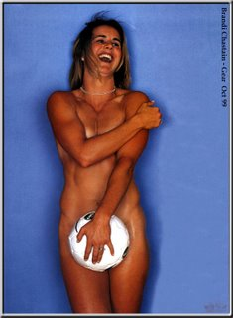

Image 2 (right): Gear Magazine Oct. 99 Brandi Chastain
http://members.aol.com/prezelski/
brandi_chastain_5.jpg
Google images.


Image 3 (left). Chastain Gear Magazine Nike ad Oct. 1999. http://members.aol.com/prezelski/
brandi_chastain_6.jpg. Google images.
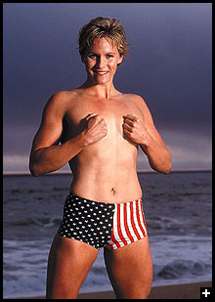

Image 4 (right) Olympic swimmer Jenny Thompson http://www.sportsbusinesssims.com/
jennyt.jpg Sports Illustrated. Google images.

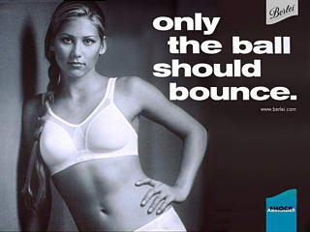
Image 5 (Left): Anna Kournikova Berlei Shock Absorbing Bras advertisement. Anna Kournicova only the ball should bounce http://titleix.files.wordpress.com/

2007/04/anna-kournikova-tennis

-is-secondary.jpg. Google Images.


Image 6 (right): Anna Kournicova Sports Illustrated cover June 2000

http://titleix.files.wordpress.com/2007/

04/anna-kournikova-tennis-is-secondary.jpg. Google images.

Image 7 (Below): Jenny Finch Sports Illustrated
http://i.a.cnn.net/si/pr/subs/siexclusive/
2005/pr/subs/siexclusive/07/05/
party0711/cover0711.jpg. Google images


Image 8 (Above): Heather Mitts and AJ Feely
QB Sports Illustrated http://www.beloblog.com/
KGW_Blogs/sports/mitts.jpg. Google images

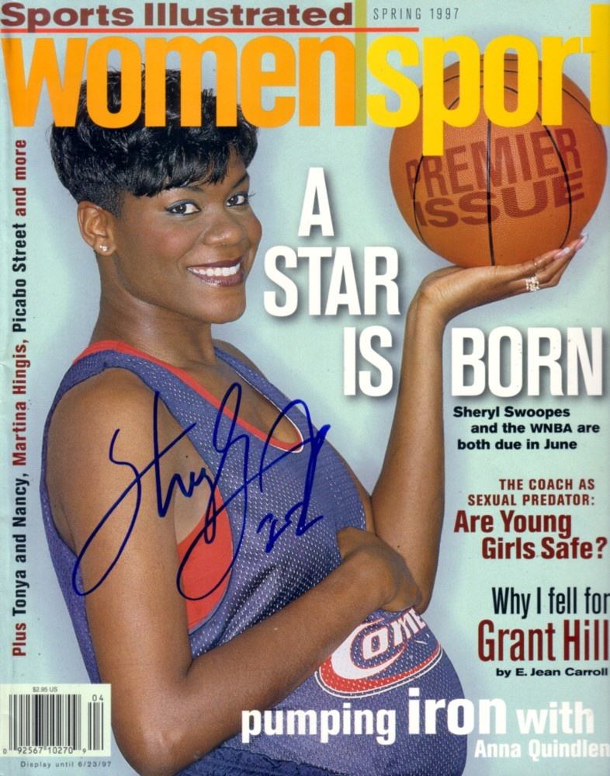
Image 9 (left): Sheryl Swoops pregnant cover of sports illustrated women 1997
http://img.underbid.com/Autographsforsale
/73776F6F706573776F6D656E73706F7274.jpg

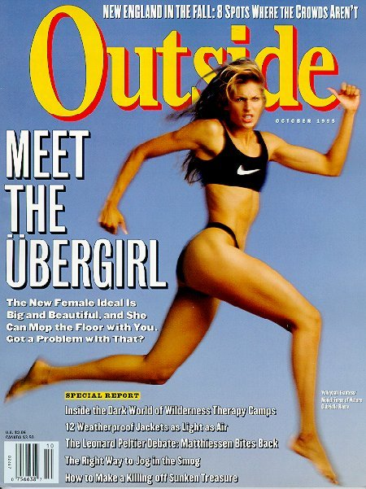
Image 11 (Below): Volley ball player Gabrielle Reece Outside Magazine Oct 1995
http://fotok.ru/cel/Gabrielle_Reece.jpg
Google images.
Image 10 (Below): Volley ball player Logan Tom Sports illustrated women-
http://www.swoo.com/39bday/logan4.
jpg Google images.
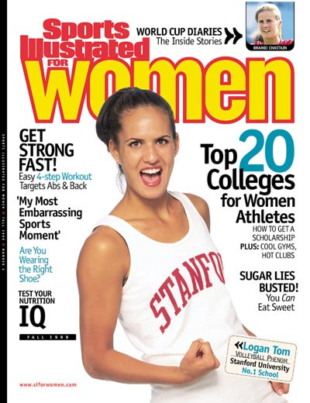


Image 12 (right): Amanda Beard U.S. Swimmer Playboy July 2007. http://i.a.cnn.net/si/2007/writers/richard_
deitsch/06/05/beard.qa/p1_beard.jpg. Google images.

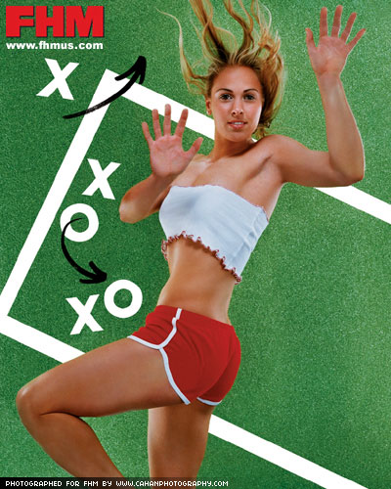
Image 13 (left): Heather Mitts For Him Magazine on glass http://img.photobucket.com/albums/v313/
evanatduke/Girls/hm5.jpg. Google images.

Works Cited

Carty, V. (2005). Textual portrayals of female athletes: Liberation or nuanced forms of
patriarchy? Frontiers, Vol. 26, No. 2 (pp. 132-154).

Duncan, M.C.(2006). Gender warriors in sport: women and the media. In A.A. Raney and
J. Bryant (Ed.), Handbook of sports media (pp. 231- 250). Lawrence Erlbaum
Associates publishers. New Jersey: Mahwah.

Griffin, P. (1992). Changing the game: Homophobia, sexism, and lesbians in sport. In J.
O’Reilly and S. K. Cahn (Ed.), Women and sports in the United States (pp. 217-
234). Northeastern University Press.

Hastings, P. (2000). In the buff: Female athletes take it all off. In J. O’Reilly and S. K.
Cahn (Ed.), Women and sports in the United States (pp. 258- 260). Northeastern
University Press.

Kane, M.J. and Greendorfer, S.L. (1994). The media’s role in accommodating and
resisting stereotyped images of women in sport. In P.J. Creedon (Ed.), Women,
media and sport: Challenging gender values (pp. 28-41). Sage Publications
London: New Delhi.

Maloney, T. (2000). A new image exposed. In J. O’Reilly and S.K. Cahn (Ed.), Women
and sports in the United States (pp. 260- 262). Northeastern University Press.

McDonald, M.G. (2005). Sporting feminism and consumer culture. In S.J. Jackson and
D.L. Andrews (Ed.), Sport, culture and advertising: Identities, commodities and
the politics of representation (pp. 24- 36). London and New York: Routledge.

Scott, B. A. and Derry, J.A. (2005). Women in their bodies: challenging objectifications
through experiential learning. In Pierman, C. J. (ED.), WSQ women and sports, Vol. 33 No.1 and 2 (pp. 188-210). Sheridan Press.

Smith, M. (2006). Reconsidering girl power: Examining media images of female athletes.
In Prettyman, S.S. and Lampman B. (Ed.), Learning culture through sports:
Exploring the role of sports in society (pp. 168-178). Toronto: Oxford
Whannel, Garry. (2002). Media sport stars: Masculinity and moralities. London and New
York: Routledge

Further Reading

Adams, N., Schmitke, A. and Franklin, A. (2005). Tomboys, dykes and girlie girls:
Interrogating the subjectivities of adolescent female athletes. In Pierman, C. J.
(ED.), WSQ women and sports, Vol. 33 No.1 and 2 (pp. 17-32). Sheridan Press.

Giardina, M.D. and Metz, J.L. (2005). Women’s sports in Nike’s America: Body politics
and the corporo-empowerment of “everyday athletes”. In S.J. Jackson and D.L.
Andrews (Ed.), Sport, culture and advertising: Identities, commodities and the
politics of representation (pp. 59-76). London and New York: Routledge.

Jones, R. and LeBlanc, R. (2005). Sport sexuality and representation in advertising: The
political economy of the pink dollar. In S.J. Jackson and D.L. Andrews (Ed.),
Sport, culture and advertising: Identities, commodities and the politics of
representation (pp. 119-133). London and New York: Routledge.

Knight J.L. and Giuliano T.A. (2003). Blood, sweat and jeers: The impact of the media’s
heterosexist portrayals on perceptions of male and female athletes. Journal of
Sport Behavior, Vol. 26, No. 3 (pp. 272-284).

Lantz, C.D. and Schroeder, P.J. (1999). Endorsement of masculine and feminine gender
roles: Differences between participation in and identification with the athletic
role. Journal of Sport Behavior, Vol. 22, No. 4. (pp. 545- 557).

Thomsen, S.R., Bower, D.W., and Barnes, M.D. (2004). Photographic images in
women’s health, fitness, and sports magazines and the physical self-concept of a
group of adolescent female volleyball players. Journal of Sport and Social Issues,
Vol. 28, No. 3, August, 2004. (pp. 266- 283).

